Risk Management

🔹 Definition
# Source: AI Source: Provided by: [Data Path: Persons Table -> ID Column: 1, Name_En Column: Motasem Essam] -> From: [Chatgpt (GPT‑5 Mini)] on [8/24/2025]
Risk Management is the systematic process of identifying, analyzing, prioritizing, and controlling risks that could impact a project, product, or business objective.
Its main goal is to minimize the negative effects of risks and maximize opportunities.

🛠️ Objectives of Risk Management
# Source: AI Source: Provided by: [Data Path: Persons Table -> ID Column: 1, Name_En Column: Motasem Essam] -> From: [Chatgpt (GPT‑5 Mini)] on [8/24/2025]
- Identify risks early in the project or product lifecycle.
- Assess the probability and impact of each risk.
- Prioritize risks based on their severity.
- Plan responses to avoid, mitigate, transfer, or accept risks.
- Monitor and control risks throughout the project.
- Document lessons learned for future projects.

🔹 Key Steps in Risk Management
# Source: AI Source: Provided by: [Data Path: Persons Table -> ID Column: 1, Name_En Column: Motasem Essam] -> From: [Chatgpt (GPT‑5 Mini)] on [8/24/2025]
- Risk Identification
  - Detect all potential risks that could affect the project.
  - Tools: Brainstorming, checklists, risk registers.
  - Example: Server downtime, delayed deliveries, budget overruns.
- Risk Analysis
  - Evaluate the probability of each risk and its impact.
  - Types: Qualitative (High/Medium/Low) or Quantitative (numeric).
- Risk Prioritization / Risk Scoring
  - Rank risks based on severity and likelihood.
  - Example: Risk Score = Probability × Impact.
- Risk Response Planning / Risk Control
  - Decide how to handle each risk: Avoid, Mitigate, Accept, Transfer.
  - Example: Adding redundant servers to avoid downtime.
- Risk Monitoring & Review
  - Continuously track identified risks and look for new ones.
  - Update risk register and mitigation plans as needed.
- Risk Documentation & Reporting
  - Maintain a risk register with all risk attributes, status, and actions.
  - Communicate with stakeholders regularly.

🔹 Example Scenario
# Source: AI Source: Provided by: [Data Path: Persons Table -> ID Column: 1, Name_En Column: Motasem Essam] -> From: [Chatgpt (GPT‑5 Mini)] on [8/24/2025]
Project: E-commerce website launch
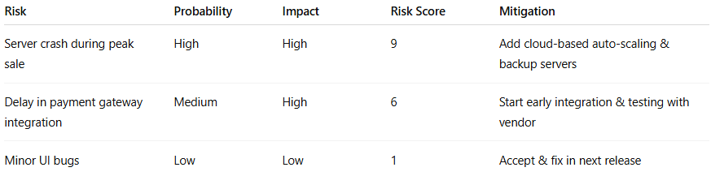
Risk | Probability | Impact | Risk Score | Mitigation
Server crash during peak sale | High | High | 9 | Add cloud-based auto-scaling & backup servers
Delay in payment gateway integration | Medium | High | 6 | Start early integration & testing with vendor
Minor UI bugs | Low | Low | 1 | Accept & fix in next release

🔑 Importance of Risk Management
# Source: AI Source: Provided by: [Data Path: Persons Table -> ID Column: 1, Name_En Column: Motasem Essam] -> From: [Chatgpt (GPT‑5 Mini)] on [8/24/2025]
- Minimizes unexpected failures or losses.
- Ensures projects stay on time, within budget, and meet quality standards.
- Improves decision-making and planning.
- Builds stakeholder confidence in project success.
- Enables proactive, rather than reactive, management.

✅ In short:
Risk Management = The structured process of identifying, analyzing, prioritizing, controlling, and monitoring risks to reduce negative impacts and ensure project or business success.

